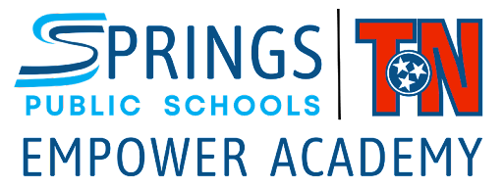

Dear Parent/Guardian:
During the school year, we take photographs of school activities involving students to share the school's positive vibe and updates. By which incidentally, some photographs may capture your child's participation, directly or indirectly.
These photos may be published through our website, social media pages, news bulletins, billboards, and ads.
With this, we seek your consent in allowing us to publish photos which may involve your child on the said platforms.
Please do provide your response by selecting your choice below and submitting this form:
Photo Release Consent
- I hereby allow the reproduction and publication of my child’s photograph(s)
- I do not allow the reproduction and publication of my child’s photograph(s)

Name of Student ____________________________________________________________________

Parent Name _____________________________________________________________________

Parent Phone Number _____________________________________________________________

Parent Signature ____________________________________________________________________

